‘They are not real’- the media’s impact on male eating disorders
Eating disorders are responsible for more loss of life than any other mental health condition, and unfortunately, are becoming increasingly more common. Many attribute this increase to social media and the representation of bodies in television.

Between 1.25 and 3.4 million people in the UK are affected by an eating disorder with 25% of the statistic being men. However male eating disorders are talked about way less and given far less coverage than female eating disorders are. Not fitting the body standard set out across the media can lead to serious mental health issues especially in young boys.
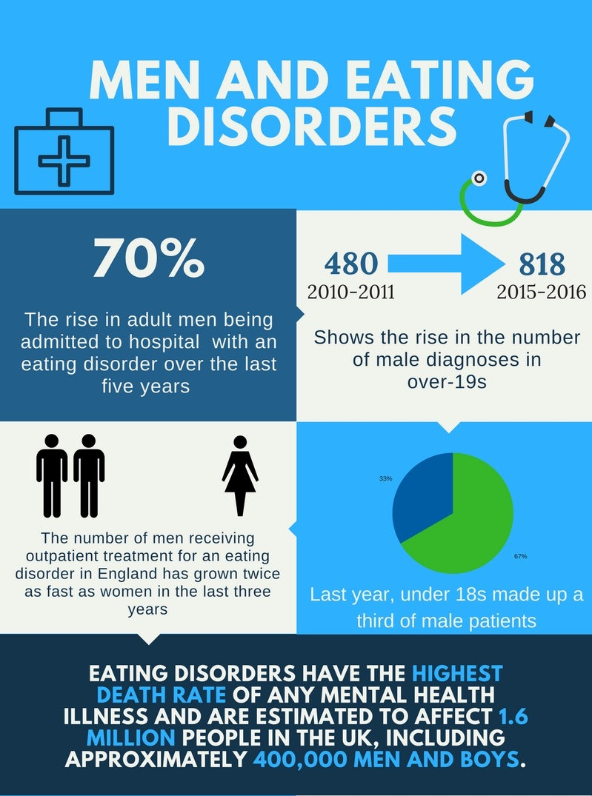

One study by the American Psychological Association showed that teenage boys who think they are too skinny when they are actually a healthy weight are at greater risk of being depressed as teens and as adults when compared to other boys, even those who think they are too heavy.

Study leader, Aaron Blashill, commented: “Teenage girls tend to internalise and strive for a thin appearance, whereas teenage boys tend to emphasise a more muscular body type. We found that some of these boys who feel they are unable to achieve that often unattainable image are suffering and may be taking drastic measures.”

This unfortunately is the case as it has been proven steroid use is much more common among those suffering with depression or being bullied. These steroids can have horrible impacts on your health that may last for the entire lives of these boys.

Louie Carey from Bexleyheath has recently recovered from an eating disorder which he suffered with for most of his teenage life and he spoke about the impact words of others had on his mental state.
“I was 18 and I was 5’10 and I weighed 8 stone 6 pounds which is heavily underweight. It was a lot for me mentally because I just wanted to look like everyone else. When you are underweight you tend to look at other people and how they look at you and you always just assume their talking about your weight even though they might not be so it’ s a lot to deal with.”

“Pretty much everyone would comment on me being extremely skinny and underweight which did hurt mentally because even now I’m at a weight where I’m a lot more comfortable I still feel underweight and I still feel skinny no matter what.”

It is not just bullying and judgemental stares however that causes mental health problems in young boys like this however as they are constantly presented with, on social media and in movies, an unrealistic and unachievable body image. Not attaining this body standard can cause people to feel as though they are not good enough.

According to the National Eating Disorder Association, a recent study of women between the ages of 18 and 25 showed a link between Instagram and increased self-objectification and body image concerns. Another study of social media users showed that higher Instagram usage was associated with a greater prevalence of orthorexia nervosa symptoms, highlighting the influence social media has on psychological well-being.

Influencer Tana Mongeau before and after photoshop. Not everything you see on social media is real

Louie argued that the media definitely influenced his eating disorder, but now he has come to the realisation that the images we are presented by the media are false. He said:
“No matter if you’re male or female there’s a standard image of what you’re meant to look like and the majority of people who do use those kind of apps alter their photos. You will never see someone for how they really look in real life ever.”

It is not just social media, however, that has this impact. Notably in movies, especially action movies, men are all presented to have the ‘perfect’ body with abs and muscles which is just not attainable for the majority of people.

“everyone you see in movies are ripped and huge and have loads of muscles and I don’t think it’s talked about enough that those people don’t get like that naturally either. People don’t understand that the way movie stars look they are not real.”
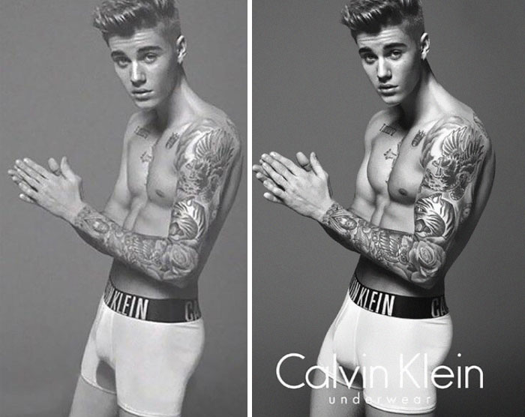

Justin Biebers famously photoshopped Calvin Klein shoot. Men photoshop their bodies too!
Going forward it would be beneficial to the mental health of all young people, being influenced daily by everything they see in the media which will shape their future mindsets, to see realistic body types being promoted. At the end of the day humans are not all meant to look the same and it should not be taught to the youth of today that only one body type is acceptable and we all must work to achieve it.

All bodies are different and all bodies are beautiful in their own unique way.

-Isobel Williams

