The Final Run! The top 25 albums on the poster!!

#25. APETITE FOR DESTRUCTION – GUNS N’ ROSES
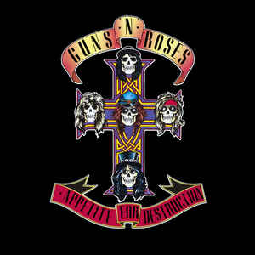
The New Era of Rock
Possibly one of the most recognisable rock groups of all times, Guns N’ Roses are one of those bands that have managed to cement themselves with the old and young. Axl Rose’s insanely whiney voice pierces like a knife and slash’s guitar solos have inspired millions of young wannabe musicians. Appetite is a hard rock album which I also have personal connections with and watching them perform live on stage as if no time has passed is an experience and a half. Appetite also has some of the most famous rock songs of all time like Sweet Child O’ Mine, Welcome to the Jungle, Night Train and my personal favourite, Paradise City, which has one of the catchiest choruses of all time. With some of the most recognisable guitar riffs of all time, I would say that Appetite is a good choice if you aren’t particularly into rock. I know quite a few people who don’t like rock… except for Guns N’ Roses. The Use Your Illusion albums, whilst different, also offer some great tracks as well, so check that out as well, if you want a more blues infused style.

#24. JOLENE – DOLLY PARTON
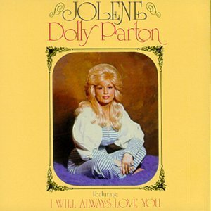
Don’t watch her Christmas movie…
Is any introduction needed? Easily one of the most famous country albums of all time, from the Queen of Country, there is little to talk about with Jolene. A short album, clocking in at 24 minutes long, is nonetheless incredibly sweet, with Jolene’s proficient skills on the guitar and her incredible vocals being the focus point of the song. Occasionally, you will find very simple and gentle drum riffs in the background of Parton. Although, many country songs are quite short, which is probably why it’s quite liked by a number of people. Jolene is also responsible for producing one of the standout performances from Whitney Houston, as we saw earlier in The Bodyguard, in the form of a cover of I Will Always Love You. The title track needs no introduction, a heart-breaking tale of marital affairs that will stay in country music for years to come, a legacy shared by the album, I think.

#23. RUMOURS – FLEETWOOD MAC
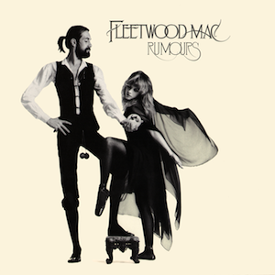
The rock and roll version of Adele
This is a common choice for number one on this list. Rumours has cemented itself as one of the best albums of the seventies, perhaps of all time. Its influence can be found from Marvel movies to Formula One advertising themes. And you know what? It really is quite good! Rumours is probably from my favorite period of Fleetwood Mac’s tumultuous timeline and tracks like The Chain, Dreams, Gold Dust Woman, and my personal favorite track Go Your Own Way go a long way to prove that. Fleetwood Mac is often measured up to their consistent break ups, splits, and the generally short life span for each of its members. Reminds me a lot of that riddle about questioning whether you still have the same boat after every plank is replaced. For my money, Stevie Nicks was around for Rumours, Tusk and Tango in the Night, so it could be argued this was their best time. But considering how I am basing that on an abridged history of Fleetwood Mac, I would not take my word as gospel. Except when I am recommending an album.

#22. THE MARSHALL MATHERS LP – EMINEM
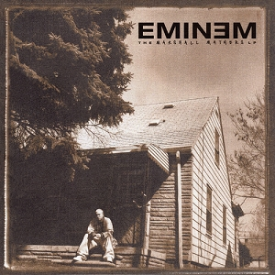
The many names of one man
Eminem is part of the Horrorcore genre; I don’t think there could be a more apt name for it. Eminem’s work speeds past intense and goes straight to terrifying, with his depictions of murder and poverty in a lot of tracks in The Marshall Mathers LP. But a lot of Slim Shady’s tracks are incredibly nuanced in their portrayal of himself and his life. I was especially impressed with the third track Stan, which (without spoiling) descends into a pretty horrific tale of mental health issues and the dangers of idolisation. The Real Slim Shady, Marshall Mathers and Kim are my personal favourite of Eminem’s controversy laden LPs. For better and worse, one of Eminem’s real talents that can’t be found easily amongst pop culture is that he will say anything. It has gone past shock value at this point, to the point where any other celebrities’ careers would be ruined if they said the things that he did. Whether it’s about other celebrities or demographics, he will say the first thing that comes to his head. I suppose if that’s your bread and butter, you’ve probably already listened to it.

#21. ELECTRIC LADYLAND – THE JIMI HENDRIX EXPERIENCE
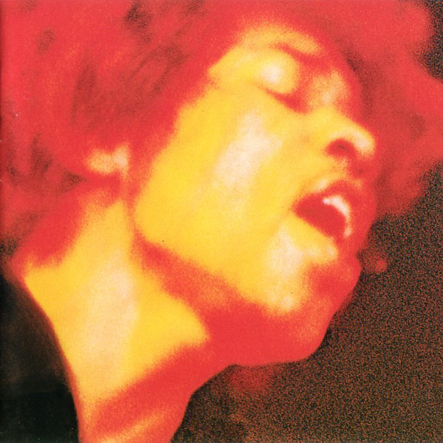
Excuse me, while I kiss this guy ↑
Get ready for another original opinion: I love Jimi Hendrix. Shocking, right? I was looking forward to Electric Ladyland, because Are You Experienced? Is one of my favourite albums ever. Furthermore All Along the Watchtower is one of the first songs I lost my mind over, so I have a leniency towards him. I hadn’t listened to Electric Ladyland, admittedly but I gathered the impression that the spotlight is more focused on Hendrix than his bandmates, which it definitely is. Hendrix’s signature play style has taken the world by storm, doing little to dispel the theory that he played better whilst he was high. The album is very long, but I would say it’s as long as it needs to be, for someone who is such a big fan of the Jimi Hendrix Experience. As a result of this, I think I prefer Are You Experienced?, despite the Sophie’s Choice I face when having to choose.

#20. BRIDGE OVER TROUBLED WATER – SIMON & GARFUNKEL
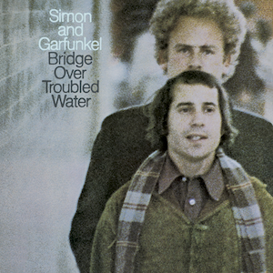
Hello Guitarists, my old friends, I’ve come to listen to you again
I suppose Simon and Garfunkel’s career is one that shows what happens when you make the other pick up the slack. In short, make your friends feel useful, or you’ll end up breaking one of the most infamous musical duets in history. Bridge Over Troubled Water is Simon and Garfunkel’s album peak, with some amazing hits in the line-up, including Baby Driver, Bye Bye Love¸ the title song, and Cecelia. However, one track that shines above the others for me is a song that has been on the tip of my tongue for months: The Boxer. A tragic and haunting tale of a young boy who leaves for New York (a very common topic for S&G) and devolves into a lifestyle that he grows to hate, along with hating himself. It’s a horrific song that really elevates this album from great to unbelievable.

#19. I NEVER LOVED A MAN THE WAY I LOVED YOU – ARETHA FRANKLIN
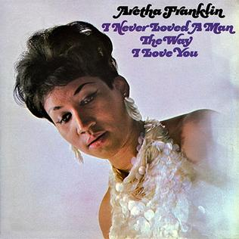
Get what you asked for: Respect
I recently had a strange experience with my 6-year-old nephew, who saw this poster, and immediately asked whether Aretha Franklin was on the list. Not only that, but he also asked me if her classic hit Respect was on the list, and he was right on both counts. This confused me a bit, because I had no idea my nephew was into music, let alone a classic figure from the fifties. And admittedly, the first time I remember hearing about Franklin was when she died. I like to think my nephew asking this shows the impact she has had on the world, and that concludes my TEDx talk about how my nephew will turn out more culturally intelligent than me in ten years. As I said earlier, I feel very stupid for not knowing who Franklin was before she died, because this album is all of my favourite aspects of soul music and shows what an absolute powerhouse of music she was. Following in the footsteps of musicians such as Ray Charles, some of Franklin’s work are covers of country music and the like, which make the music sound much more accessible into a genre that is widely shunned. In many ways, I Never Loved a Man the Way I Loved You is one of the best soul albums of all time, and worth a check.

#18. BEYONCÉ – BEYONCÉ
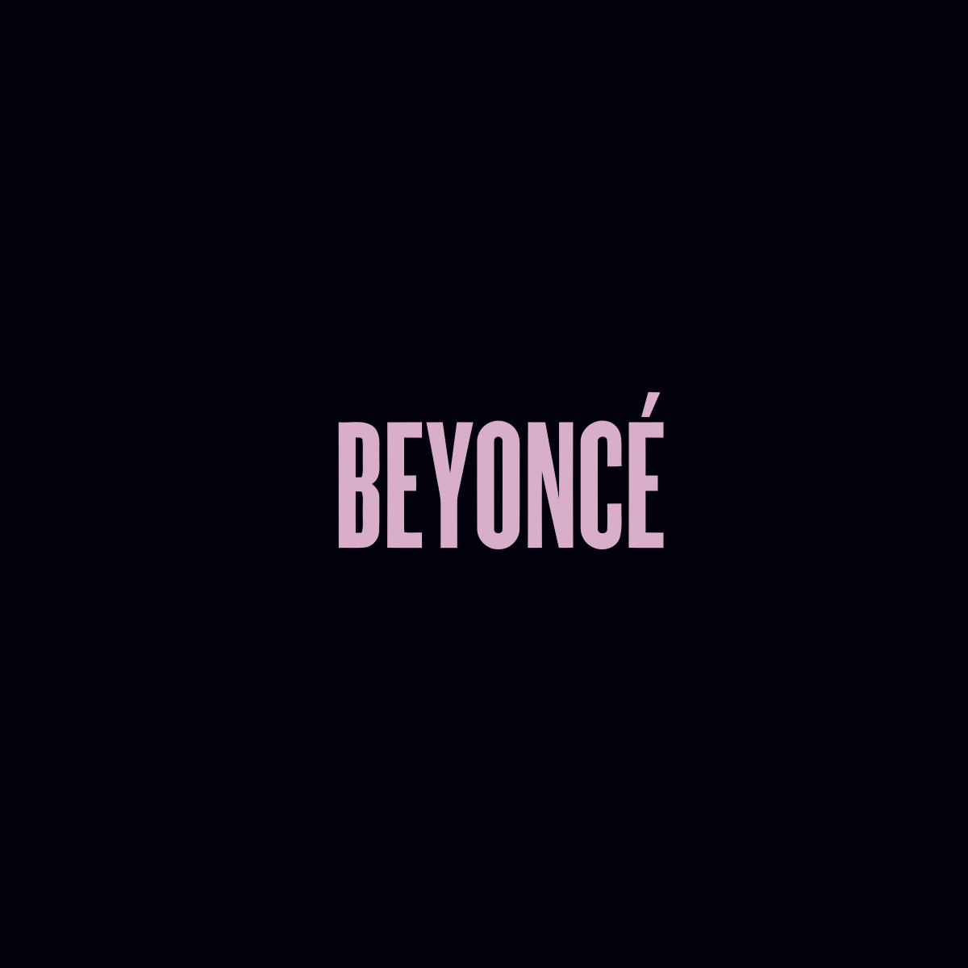
Would not surprise me if she actually did Run the World
On a different note, I genuinely would love to meet someone who has never heard of Beyonce. Think about what else they might NOT know? Queen B’s self – titled album is a solid swing and a surprising choice for the poster. Amongst the biggest names in music, Beyoncé may not feature her most well-known songs, either from her early solo days or her most recent work but is a very underrated album. Beyoncé has a fascinating way of approaching music, with her incredible voice carrying simple melodies in a combination of R & B and Soul. Beyoncé also features appearances from other artists, some of whom also feature on the poster, like Kanye West, Frank Ocean, Jay Z (marriage goals) and other artists like Pharrell Williams, Drake and Nicki Minaj. Quite a line-up! Beyoncé is a combination of what makes the New Queen of Soul such a compelling act and is a great place to start if you somehow have never heard of her. 4 is another great album, and I AM… SASHA FIERCE contains arguably her best works, which may dwarf that of her self – titled album. An absolute treat either way.

#17. ILLMATIC – NAS
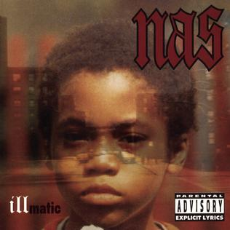
Who’s world is this?
In all honesty, the remaining albums on this list could all tie for at least number two on this list. But I have to put them in some logical order to finish the ranking! Illmatic didn’t just deliver on its promise of being a great album, it exceeded any expectations I had. Of all the rap albums I have listened to on the list, I have listened to this one the most, (excluding one). I think it’s fair to say I have a fondness more for east coast rap then west coast, and Nas’ rapping and writing skills go a long way to prove why I prefer it so much. Like many other albums on the list Illmatic is somewhat semi – biographical, depicting his upbringing in a relatively poor in Queensbridge, Brooklyn. This obviously lends itself to his style of writing, including themes of drug and gang violence. None of the tracks on Illmatic are weak, but the strongest of the bunch are New York State of Mind, Life’s A Bitch, and my personal favourite The World Is Yours, featuring one of my favourite rap hooks of all time. Even the album cover gives me chills.

#16. THE QUEEN IS DEAD – THE SMITHS
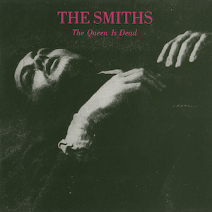
A Royal Procession
Another album I had no idea what to expect from, The Smiths are a name I was definitely familiar with but couldn’t place one of their works for the life of me. I mean, with an album cover like The Queen Is Dead, I doubt you’re going to get much indicator of what the music is like. But maybe that’s for the best. The Queen is Dead was one of the albums on this list I fell in love with almost instantly, I wanted to listen to it again just after I had finished it. Morrisey, despite being an anti – everything nutcase, has a high baritone voice that is perfect for the emo type of music that he and his band are aiming for. The title track is probably my favourite song on the list, but There Is A Light That Never Goes Out and Frankly Mr Shankly are lyrically genius and are some of the most wickedly funny songs on the poster. I am, however, deducting points as none of the band members are called Smith, which is false advertising.

#15. THE JOSHUA TREE – U2
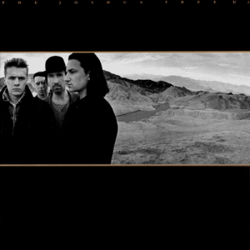
The Promised Land (?)
I was dreading listening to The Joshua Tree. Horror stories about lead singer Bono and his ego the size of the country he sings about, as well as rabid fans that find a way to insert U2 into every conversation made me wince at the sight of Ireland’s biggest rock band on the poster. But when the first notes of Where the Streets Have No Name hit me while I was shopping for dinner ingredients in Asda, any worries I had were completely eliminated. A loose concept album singing about the incredibly idealised traits of America, U2’s fifth album remains the bands peak in an otherwise amazing career. Where the Streets have no name is a song I clearly have a personal connection with, but In God’s Country, With or Without You and I Still Haven’t Found What I’m Looking For prove that there is nothing to worry about.

#14. SUPERNATURAL – SANTANA
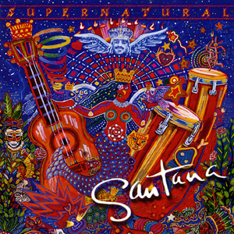
Like the sirocco
I have noticed Latin Rock is making a mainstream appearance in recent years. As a massive fan of Ritchie Valens and Carlos Santana, this makes me happy, because Latin Rock is absolutely incredible, especially proven by Santana. This was one of the few albums I was actively looking forward to, and it did not disappoint, by any measure of the word. What I wasn’t expecting was a combination of other well-known musicians, like Lauryn Hill, CeeLo Green and Eric Clapton, a wide variety of genres showing how well Latin Rock can fit into other types of music. Rob Thomas, lead singer of Matchbox Twenty, is one of the most famous collaborators with Santana, for the single Smooth, which is one of the only songs to top the charts in two different millenniums, a feat we will never see again in our lifetimes, methinks. If you can’t tell, this is one of my favourite albums of all time, and I insist you listen to it.

#13. PURPLE RAIN – PRINCE
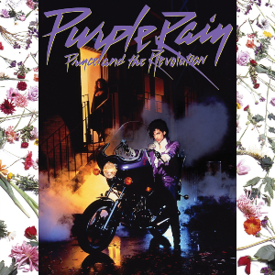
Objectivity, lost like tears in the rain
Questionable movies aside, Purple Rain has always been one of my favourite albums ever. I probably listened to Prince a year or so after his death, and he has been one of my most consistently favourite artists. And with Prince, always followed Purple Rain. The title song is iconic and very famous for its use of synthesizers, as well as its mysterious lyrics. When Doves Cry is probably my favourite track on the album, with its insane guitar solo towards the end of the track, proving why Prince was an amazing musician. Purple Rain is definitely worth every penny you may or may not pay to listen to it.

#12. BREAKFAST IN AMERICA – SUPERTRAMP
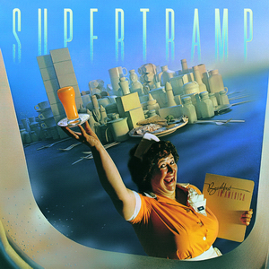
The perils of hyper – capitalist America
Here’s another album that blew my mind when I first heard it. Out of the ten songs on the album, only three of them are not on one of my playlists. If you haven’t been able to tell by now, jazz – rock absolutely dominates my life, and Supertramp is a welcome inclusion into living in my head, rent – free. If you know one song from this album, it’s probably The Logical Song with its brilliant wordplay and infectious tune, but other songs like Goodbye Stranger, Gone Hollywood and especially Child of Vision have been on my mind for quite a long time after first listening. Rick Davies rules on vocals and piano, taking songs away on incredible adventures, involving saxophones and electric pianos. This is one I recommend to anyone, it’s an incredibly easy listen, and (like the following) is one of my new favourite albums of all time.

#11. QUADROPHENIA – THE WHO
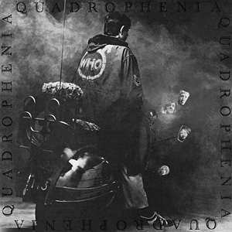
20th Century Quadraphoid Man
Perhaps the most rock – opera themed album on the list, Quadrophenia tells the tale of a London – born mod, and his struggle to adapt to society, whilst fulfilling his own base wants. The narrator (with Pete Townsend singing) eventually makes it to my not quite home city of Brighton where he goes on a quest of self-discovery. Even on second listening, the album has continually grown on me, with standout tracks such as The Rock, The Dirty Jobs and Doctor Jimmy comprising the album. Although, Quadrophenia is a weird choice for the poster, when the much more famous Who’s Next could have also made the list, in my personal opinion. Combining The Who’s signature sound of leading synthesisers and piercing electric guitar elements, Quadrophenia is still an excellent album for listening, depicting an incredibly sympathetic character on a recognisable quest. Quadrophenia does not stand the test of time in some senses. Like a fair number of albums on this list, Quadrophenia is at its best when listened to in track order, which doesn’t fair well against today’s obsession with playlists that zip from different artists and albums every five minutes. Certainly, give this one a try if you are fond of rock operas like The Rise and Fall of Ziggy Stardust.

#10. THE DARK SIDE OF THE MOON – PINK FLOYD
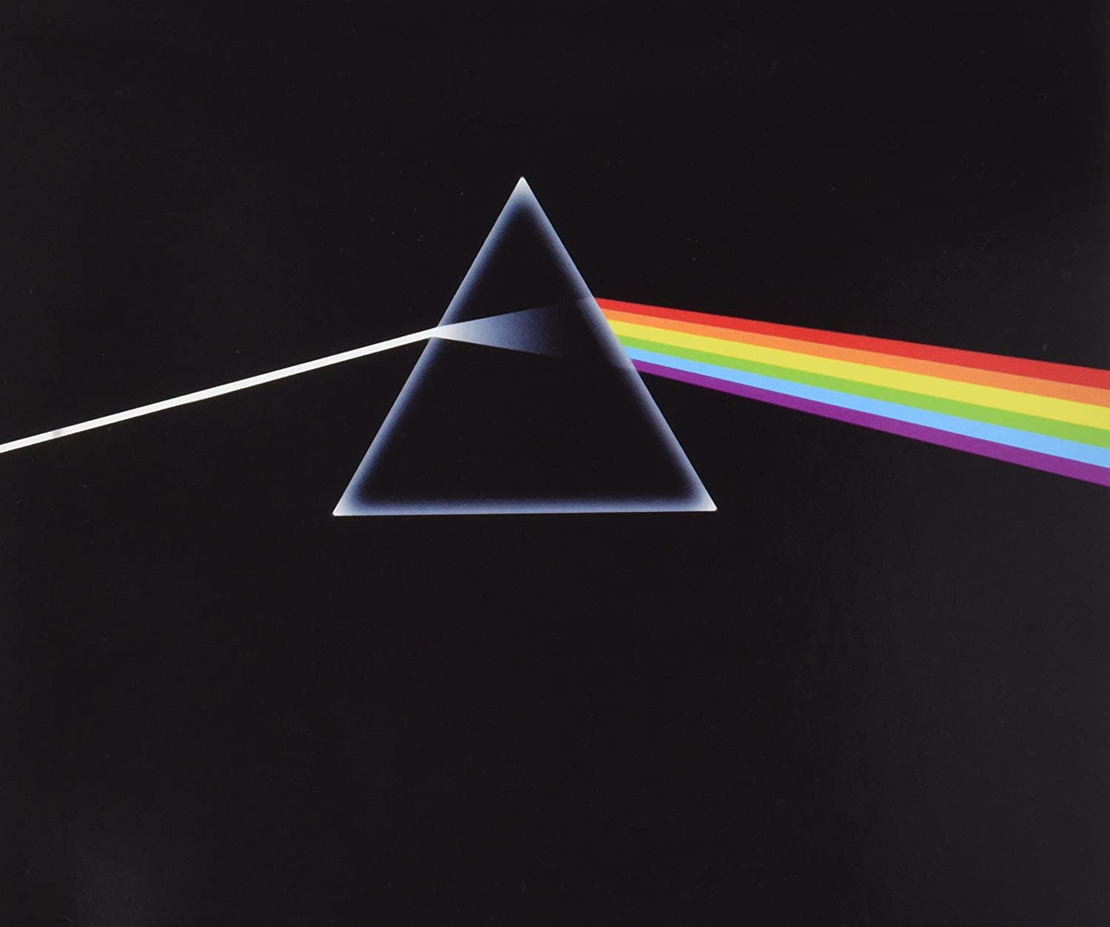
I really wanted to hate it…
If you’re still reading perhaps the most indulgent blog the CfJ may have ever seen, then you’ve heard me say this a lot, but this one was ALWAYS going to be here. That cover is everywhere, you can't get away from it! Students and seniors all display it proudly in their offices or bedrooms. Covering some of the key worries that people experience in life (fearing time, wanting more money) The Dark Side of the Moon is a pretty definitive example of why Pink Floyd are often cited amongst the greatest bands of all time. It is an album that, despite sounding like something you would find in the late 70s, is quite easy to jump into and experience. I am very fond of tracks that bleed from one to the next, perhaps using a constant sound to mask the track skip, of which this album uses in spades. David Gilmour’s epic guitar work, as well as vocal appearances by Clare Torrey and other backup singers brought me around to loving this album, despite a pretty lukewarm first listen. Is DSOTM great? Yes. Is it Pink Floyd’s best album? Hell no! DSOTM is great, but Wish You Were Here is one of the best albums of all time, in one of my hottest takes. Both are great, but Wish You Were Here is special.

#9. SONGS IN THE KEY OF LIFE – STEVIE WONDER
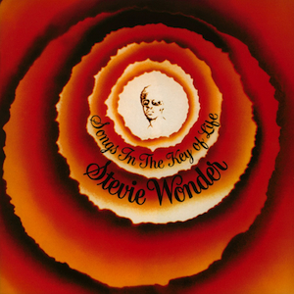
Computers can make good music!
The first of two blind artists on this list, Stevie Wonder kind of changed everything through the use of his synthesizers and his mastery of many different instruments. It is fascinating to me that an artist basically working on his own has managed to compile one of the longest albums on this list. And it is a fantastic listen! Something I noticed when listening to this album was how many of these tracks were sampled by other artists, a lot of which are on the poster as well. A Tribe Called Quest, Coolio, 50 Cent and Snoop Dogg. Ever heard of Gangsta’s Paradise, amongst the most famous hip hop songs of all time? Sampled from Pasttime Paradise, one of my favourite songs on the album. I had no idea! Quite a surprise! The first half of Songs In The Key Of Life is good enough on its own, but after Isn’t She Lovely, Stevie Wonder enters a league of his own. Other great tracks like Sir Duke, I wish and the confusingly titled As make up a great album which summarise the way Stevie Wonder conceptualises music. The four bonus tracks are pretty good, but I wouldn’t have missed them, and we would have ended on one of my favourites tracks Another Star

#8. PET SOUNDS – THE BEACH BOYS
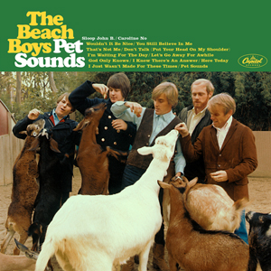
Very good vibrations
It is difficult to describe Beach Boys most famous album. In Pet Sounds, The Beach Boys demonstrate their range as a group, with the use of strange instruments such as an accordion and French horns in a number of their songs. One of the older albums on the list, Pet Sounds may very well be responsible for the majority of the albums on this list. It is regarded as one of the very first concept albums, using a central theme of adolescence and the longing for home. Released in 1966, Pet Sounds expanded on what could be considered a rock song. If that somehow hasn’t convinced you, the album features stellar tracks: Wouldn’t it be Nice, God only Knows, Caroline, no and especially Sloop John B. The Beach Boys manage to write a number of songs with incredibly sad lyrics, to the tune of upbeat and recognisable themes. Easily one of my new favourite albums, wrapped in a bitesize 28-minute runtime.

#7. THE COLLEGE DROPOUT – KANYE WEST
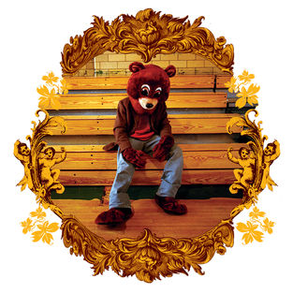
He was right about Single Ladies…
If you had told me (at the beginning of 2020) that I was going to listen to every Kanye West album by autumns end and was going to basically fall in love with his work, I would have laughed in your face. Yet here we are, and I still don’t believe it. The College Dropout is one of three albums sporting the infamous teddy mascot on its front cover, and deals with issues such as self – consciousness, poverty, family relationships and racism. Chipmunk Sound is an engaging form of rap, especially in The College Dropout, where West samples other music to excellent effect, and brings in other rappers such as Jay – Z and Jamie Foxx to contribute to the album. Being Kanye’s debut album as well also helps. Who knows how different everything would be, for better and worse, if Kanye hadn’t arrived? The world would be a lot less controversial! While The College Dropout is pretty excellent as an album, it’s not my favourite West album. Late Registration and especially My Beautiful, Dark Twisted Fantasy are where I can find my favourite Kanye West songs.

#6. WHAT’S GOING ON – MARVIN GAYE
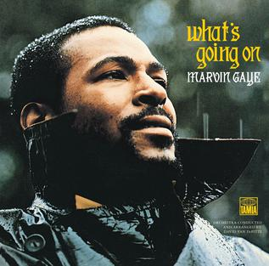
The sadness of reality
Rolling Stone’s so – called best album of all time rubbed me the wrong way, especially after the music magazine received the biggest dressing down of its lengthy history for its best albums of all-time list. However, there is no denying that this is a fantastic choice for what is an absolute achievement in all forms of music. The title song of Marvin Gaye’s politically charged album was my second most listened to song in 2020, which is pretty amazing when you consider how I only started listening to it about mid-October. Nothing about this album is wasted: it’s perfectly sung and written, and at a perfect length of just under forty minutes, there’s no reason to bang out Marvin’s soul smash almost every day. Which is what I have been doing. And if you are somehow unsatisfied with this album, check out Let’s Get It On, a similarly solid soul album.

#5. THRILLER – MICHAEL JACKSON
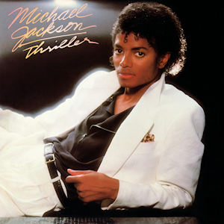
The Art and the Artist
Thriller is a fantastic album, despite the accusations thrown at Michael Jackson. Leaving Neverland, whilst demonstrating the horrible things Jackson may have been capable of, shouldn’t have come as a complete surprise to anyone, considering the high-profile court case against him back in 2005. The director has also stated he isn’t interested in cancelling Michael Jackson, so I think this situation is best left to the listener. There is no denying the brilliance of Thriller, however. It is comprised of some of the best pop songs of all time that need no introduction: Thriller, Beat It, Billie Jean, The Girl is Mine and Human Nature are a few of the fantastic songs that the best – selling album of all time is ladened with. Obviously, Jackson’s sordid past and his capability of abuse will pose a moral dilemma for all listeners for the years to come. Should we support a man who very possibly hurt young children? Is his own abuse, suffered at the hands of his father, worth considering? Is Michael Jackson too big to fail?

#4. BACK IN BLACK – AC/DC
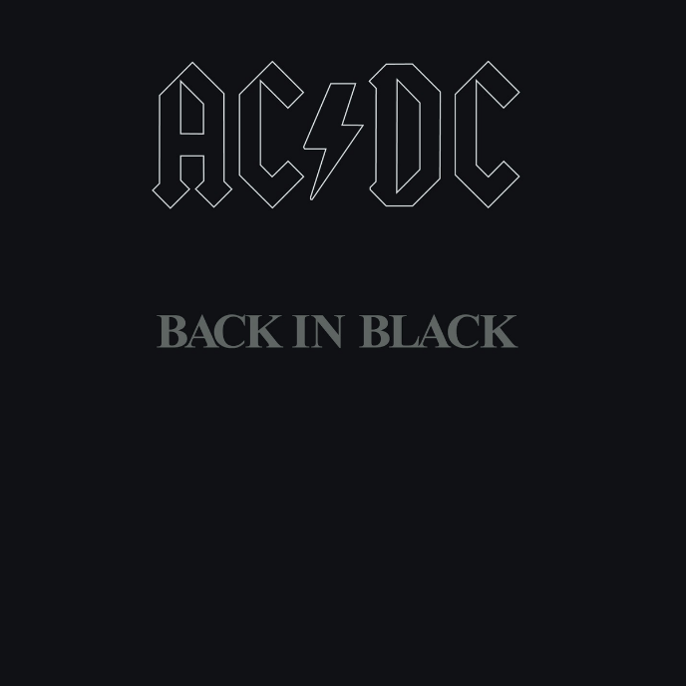
Filthy Acts at a Reasonable Price
AC/DC are yet to release a traditional greatest hit album, in the same way ABBA, Marley and Madonna have on this poster, but it would be surprising if any of the songs from this staple of an album were left out of it. Its lead single probably has one of the most recognisable and catchy hooks in all of music and is often considered amongst the best rock songs of all time. Even then, its compounded by other excellent tracks like Hell’s Bells, Shoot to Thrill, You Shook me All night Long and Have a Drink on Me. All of the songs from this album are everywhere in pop culture, from public events to early Marvel Cinematic Universe movies. Its shrieking guitar solos and pumped – up beats are recognisable everywhere but aren’t overpowering like a lot of the albums on this list. I have been listening to it for years, and it doesn’t get old.

#3. MODERN SOUNDS IN COUNTRY AND WESTERN MUSIC – RAY CHARLES
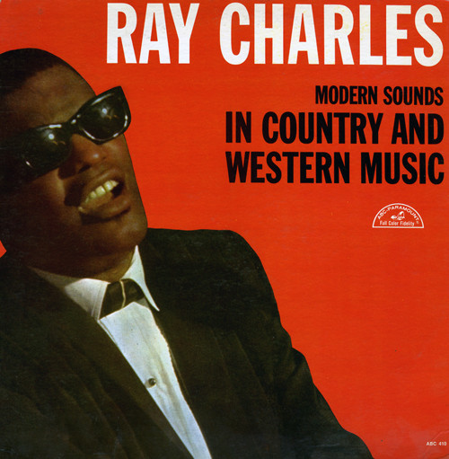
The most important album of all time?
Of the 100 Albums on the poster, I had never fully listened to 95 of them. Of those 95, Ray Charles’ Modern Sounds in Country and Western Music is easily my favourite of the bunch. An incredible selection of beautiful songs, whilst not written by Charles, shows the genius manner in which he perceived music. Clocking in at a reasonable one hour and fourteen minutes, Modern Sounds in Country and Western Music sees Charles take some of the most popular songs in Country and Western and successfully blends Rhythm and Blues to make an amazingly touching and in-depth sound. Historically, this album is hugely significant, representing one of the first examples of complete artistic control over an album by an African American, a huge milestone at the height of the Civil Rights Movement. Ray Charles’ contribution to music, not only through this album, will likely never be fully comprehended, both in the way he inspired thousands of his fans, and the cultural and racial barriers which he broke. This is an album I believe everyone should listen to, and absolutely deserves to be on the poster.

#2. LED ZEPPELIN IV (OR RUNES)– LED ZEPPELIN
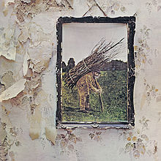
Whole lotta love for these guys
It would be quicker for me to state the aspects about Led Zeppelin IV that I don’t love… Led Zeppelin is misspelled on my poster, to look like Zeppezlin? Take that otherwise perfect album! I’ve loved Led Zeppelin for years now and Runes has always had my favourite rock songs of all time. Stairway To Heaven has been played to death, but is still unbelievable, and doesn’t get old for me. other great selections of hard rock include Black Dog, When The Levee Breaks and The Battle Of Evermore. Rock and Roll, in particular, is a song that has recently grown on me since revisiting the album and is a great revisitation of classic rock by way of Chuck Berry. A head – banging bop of an album that was always going straight to the top of the list.

#1. BORN TO RUN – BRUCE SPRINSTEEN
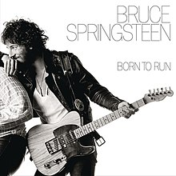
The end of the road
And here we are. My favourite album of all time, one that I wouldn’t change any aspect of. The brilliant jazz - rock combo that is The E Street band’s masterpiece. I have listened to this album too many times, and I will continue to listen to it for the rest of my life, my comfort zone. Springsteen’s low voice might be a bit off – putting for some, but no other voice could adequately replace him. Clarence Clemmons incredible saxophone solos, especially in the concluding track Jungleland, are amongst the best in musical history, powerful and filled with emotion. As I said earlier, the last 15 or shift between ranks so quickly, but I think Born To Run will always stay at number one, and one that will always be my go-to when I’m recommending an album. A modest, impressive, and occasionally emotional album that showcase why jazz and rock go so well together.

And that’s the list. If you are still reading, thanks for indulging me, it makes the effort worthwhile. I might sound ungrateful in some of my reviews, but I would like to say that all of these albums are probably worth a listen, simply for the fact you may have never heard of them and could be one of your new favourites. And I would like to remind you the disclaimer is STILL in place; if there is an album that isn’t on the list that isn’t on there, then you aren’t on your own. I even have a couple of suggestions that could replace some albums, as you have seen. And I don’t want to be stopped in the middle of my work to hear that my opinion is crap because I put an album in the wrong place, I’m fine to do that on my own. Other than that, what did you think of the list? I’m genuinely interested to hear your thoughts. See you soon! 😊

