The effects of tourism on sea life

The big blue ocean is home to millions of sea life, but it is also a source of income for the 60 million people working in the marine fishing industry and a protein source for human consumption. Not to mention it also being a holiday destination for millions of tourists yearly.
It is not new to hear that we are facing a crisis when it comes to endangered sea life and water pollution. Scientists are predicting that 90% of coral reefs could disappear by 2050. Unsustainable tourism is a major factor that contributes to coral reefs dissipating. For example, careless divers, badly placed boat anchors and hotels discharging untreated wastewater inevitably pollutes the ocean and creates sedimentation which encourages the growth of algae that compete with corals. The ocean’s biodiversity is deteriorating at an alarming rate, mostly due to human activities.
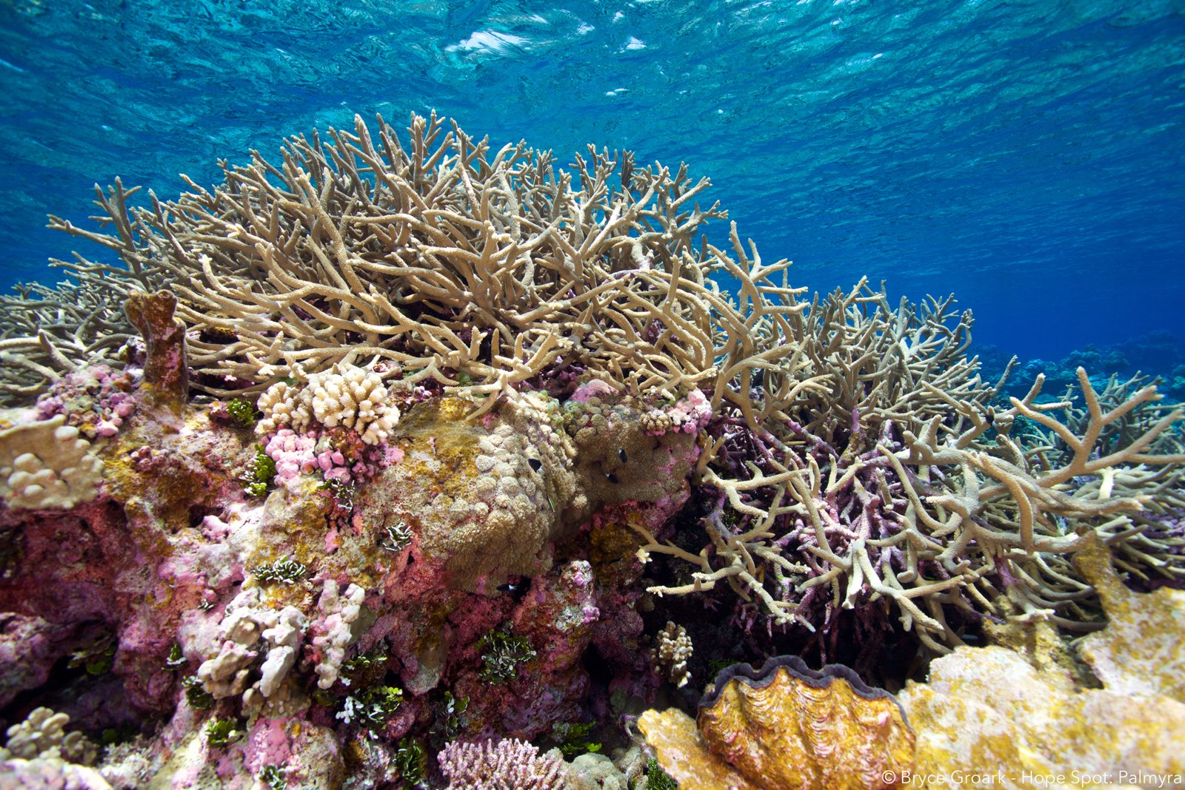
With the existence of generational progress in terms of a growing middle class, this has meant that travel has become more accessible than ever with an unlimited number of destinations to choose from. According to the Statista Research Department, the number of international tourist trips worldwide reached 1.4 billion in 2019 and is predicted to reach 1.8 billion by 2030. The influx of beachgoers has meant that the use of sun protection products has increased too, and as a result, there is a buildup of toxic sunscreen in the sea. 14,000 tonnes of toxic sunscreen are found underwater around the world each year. This, along with water pollution, coral diseases and rising sea temperatures lead to deformations in premature corals preventing them from growing, reproducing and surviving.

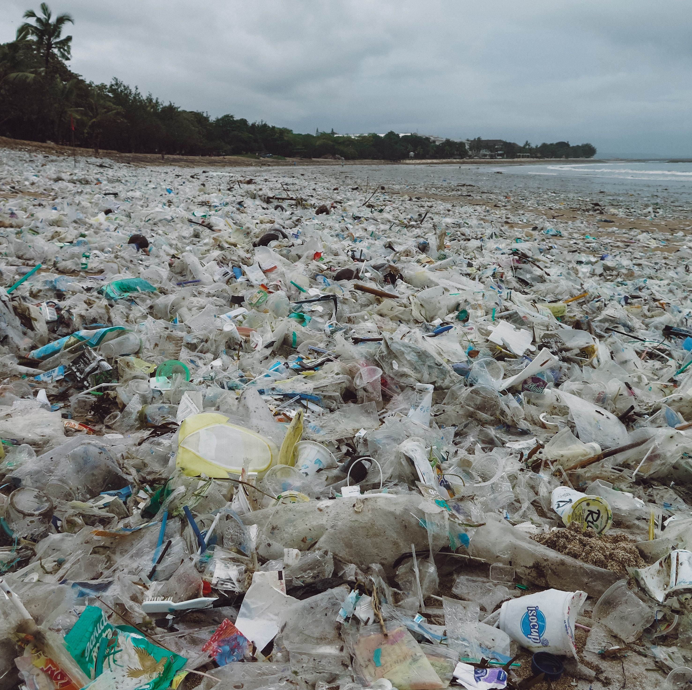
More tourism means more people. Unfortunately, more people can sometimes mean more litter, especially on beaches. Around 40% of all plastic is in single-use packaging and littered beaches are found with straws, coffee cups, water bottles, etc. These items are detrimental to sea life, causing ingestion, suffocation and entanglement to hundreds of marine species. Recently, there has been an influx of purchases of reusable items which are better for the environment, such as collapsible coffee cups and metal straws. The existence of strategic partnerships allows the public and private sector to reduce plastic waste, develop a circular economy and build sustainable communities while protecting our sea life.
All in all, tourism has both advantages and disadvantages. It is pivotal to find the balance between encouraging human mobility and stimulating viable incentives for the conservation of our seven seas.

